**ICT171 –Assignment 2: Cloud Server Project**

Name: Oshandi Jayasekara

Student ID: 35043305

Unit Code: ICT171

Assignment Title: Assignment 2 – Cloud Server Project

IP Address: [170.64.203.136](http://170.64.203.136/)

**Introduction**

For the assignment, I needed to create and configure a cloud server. I created a server using DigitalOcean and installed Ubuntu version 22.04. I installed Apache2 to serve up a static HTML web page. I accessed the cloud server using SSH and modified the default index.html file to show a portfolio message.

**Screenshots**

Screenshot 1: General overview of DigitalOcean project and Droplet.

Screenshot 2: Droplet dashboard showing IP

Screenshot 3: Enters SSH login to Droplet (first login).

Screenshot 4: Apache2 default page before edit

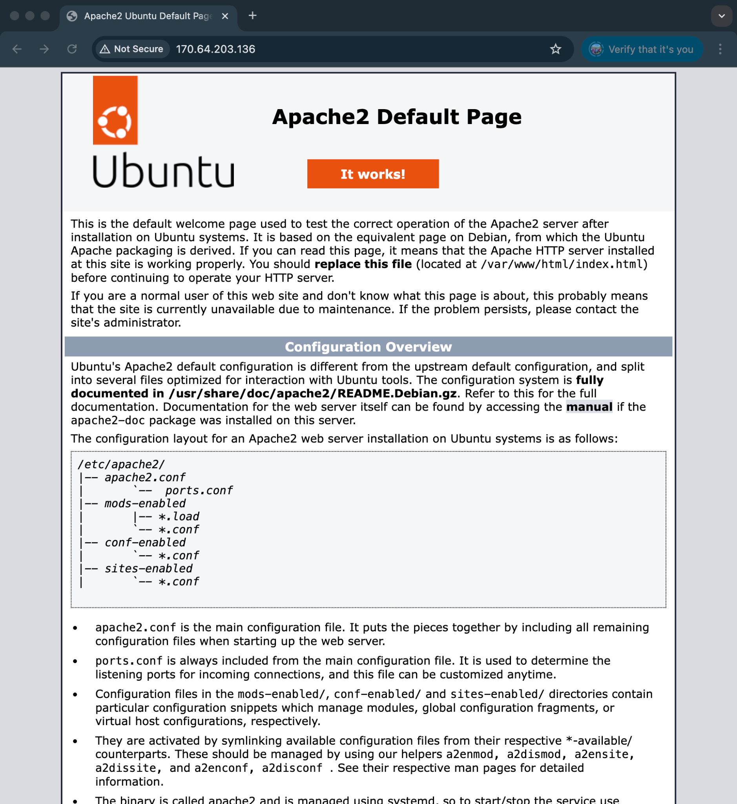

Screenshot 5: Editing index.html with portfolio content

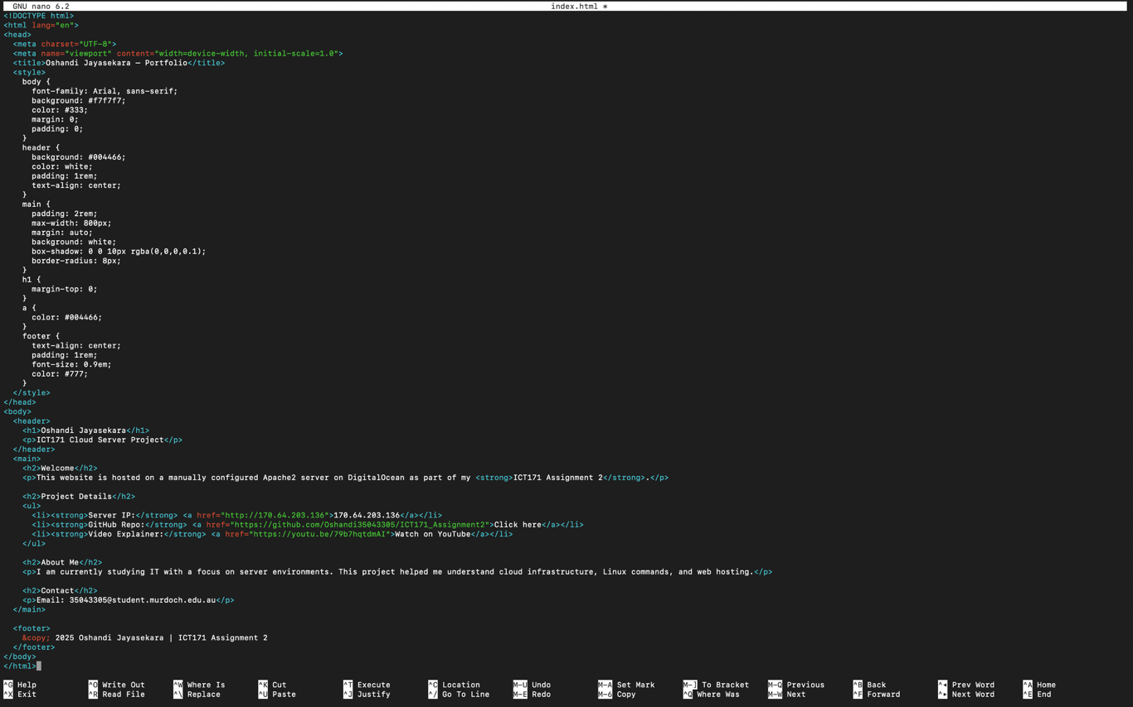

Screenshot 6: Final HTML page in the browser, showing your portfolio.

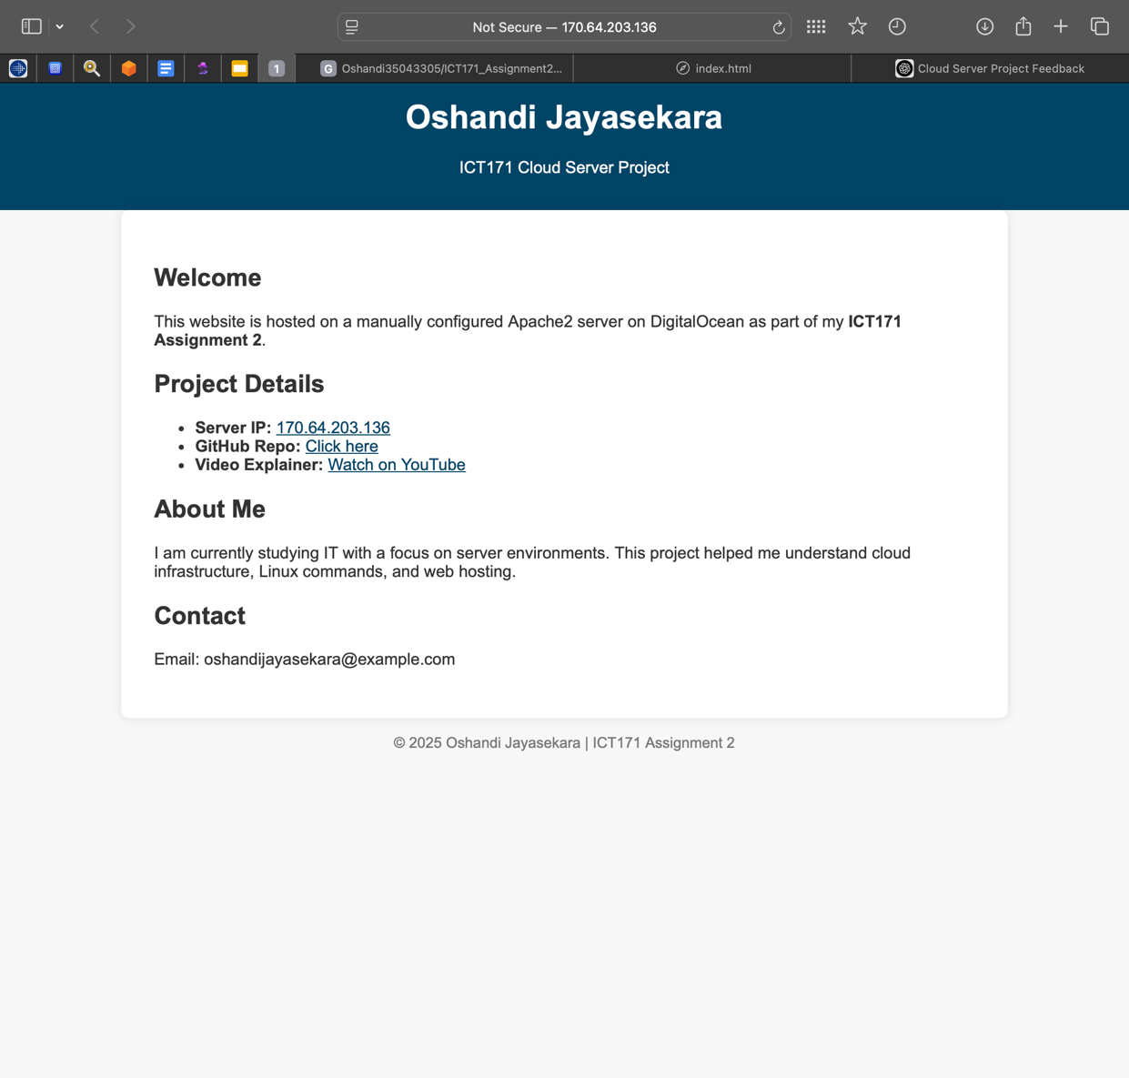

**Reflection**

In this assignment I learned how to deploy a basic cloud server, and how to host web content using Apache. Initially I struggled with editing HTML in the terminal, however I learnt how to use "nano". I also struggled with understanding the SSH setup, which I now have a clearer grasp of. I do want to automate some parts in the future and may look into some form of script for time management. Overall, I enjoyed the learning experience in relation to Linux server administration and cloud computing.